Psychological statistics
Homework Assignment ③
B812109041 Isaac, Lee

- ESSAY GRADE
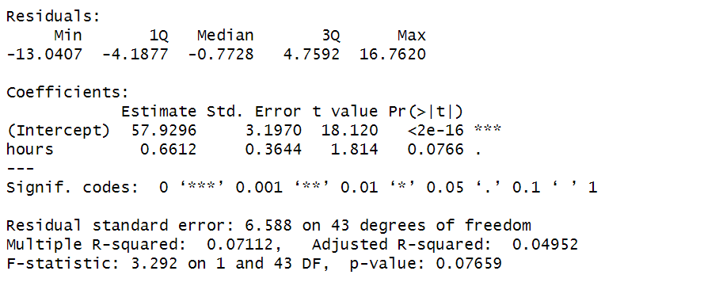
Adjusted R – squared: 0.04952.
Conclusion:
The fitness of the linear model is relatively low, and the positive correlation is less evident.
- CHECK THE PAPER
  - Calculate the correlation coefficient between CAQ scores and AUT fluency.
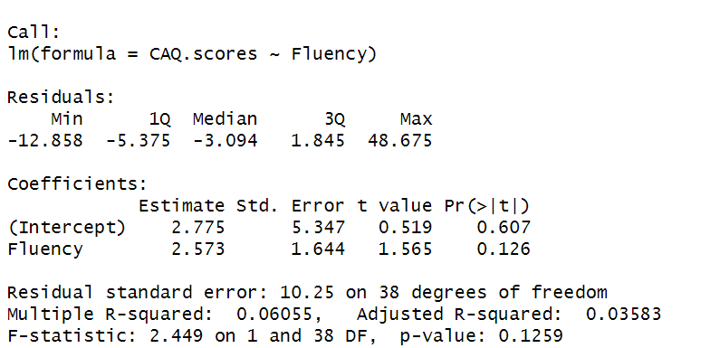
Adjusted R – squared: 0.03583 / p-value: 0.1259.
  - Calculate the correlation coefficient between CAQ scores and AUT originality.
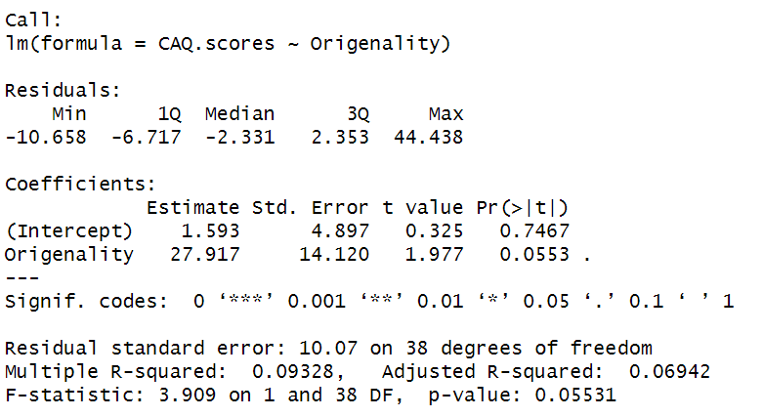
Adjusted R – squared: 0.06942 / p-value: 0.055331.
  - Compare the CAQ scores between the high creativity group and the low creativity group.
I used t.test to compare the two groups, but I couldn't successfully divide the data frame into high-score group and low-score group.

- SUPERMODEL
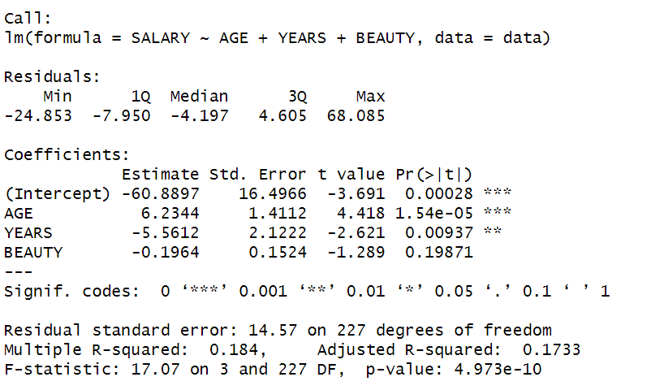
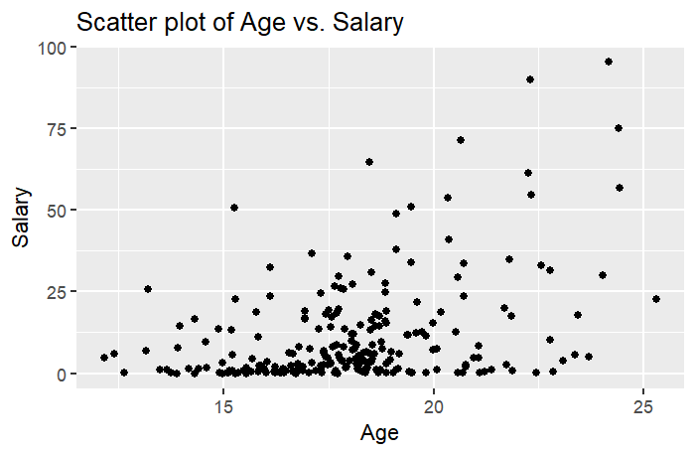
Scatter plot of Age vs. Salary
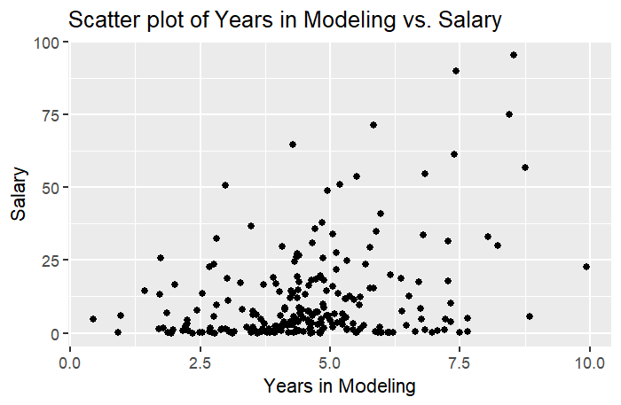
Scatter plot of Years in Modeling vs. Salary
Conclusion:
- Age has a significant positive (coefficient = 6.2344, p = 0.00028) effect on salary, meaning that as age increases, salary also increases accordingly. On the other hand, the number of years spent in the modeling profession has a significant negative effect (coefficient = -5.5612, p = 1.54e-05) on salary.
- The attractiveness rating, however, does not have a statistically significant effect on salary prediction. (R-square = 0.1733)

- CHILD AGGRESSION
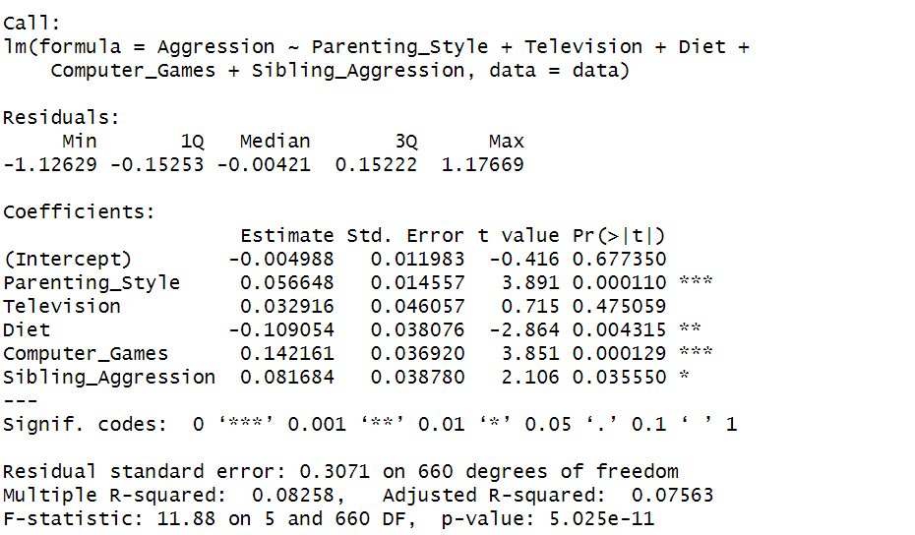
According to the regression analysis results:
1. Interpretation of Coefficients
- The coefficient for Parenting Style is 0.0566, with a standard error of 0.0146 and a significant p-value (< 0.001), indicating a significant positive effect on aggression.
- Television and Sibling Aggression show some influence but are not statistically significant.
- Diet and Computer Games have a significant negative impact on aggression, meaning that more time spent on diet and computer games is associated with less aggression.
2. Model Fit
- The model's R-squared is 0.08258, indicating that it can explain about 8.26% of the variance in aggression, suggesting a relatively low overall explanatory power.
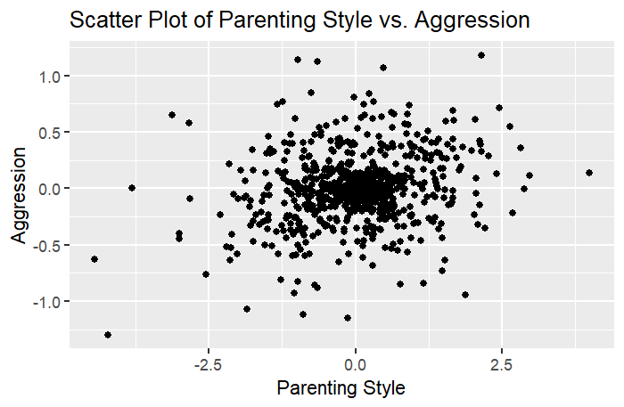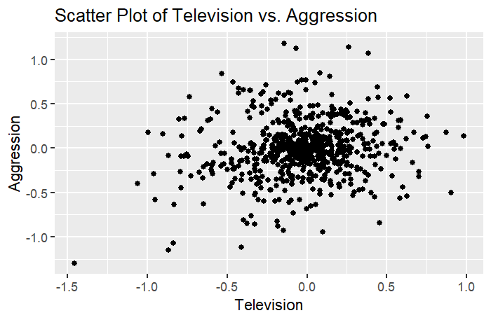
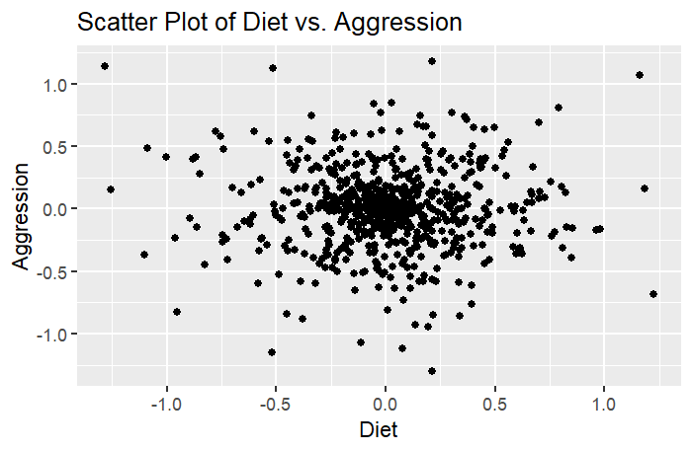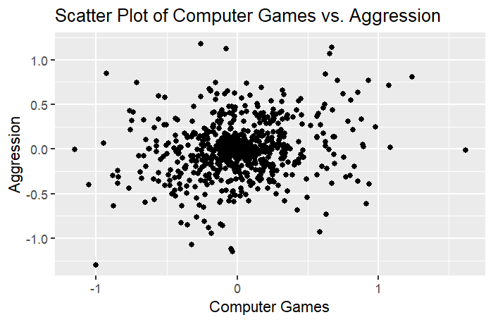
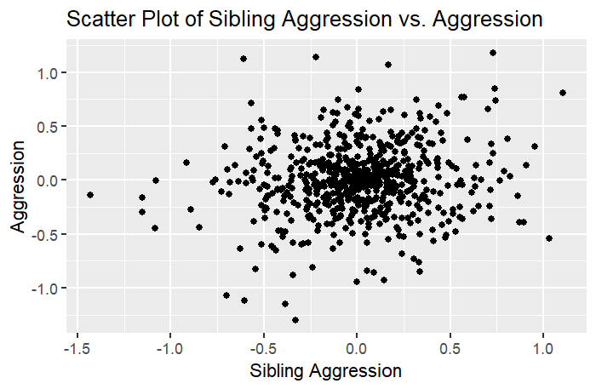
Conclusion
Overall, these results suggest that Parenting Style, Diet, and Computer Games may significantly influence children's aggression, while Television viewing and Sibling Aggression have a lesser, or even insignificant, impact. This supports previous research indicating that Parenting Style and Sibling Aggression are important predictors of children's aggression.

